**How Java Program Runs->**

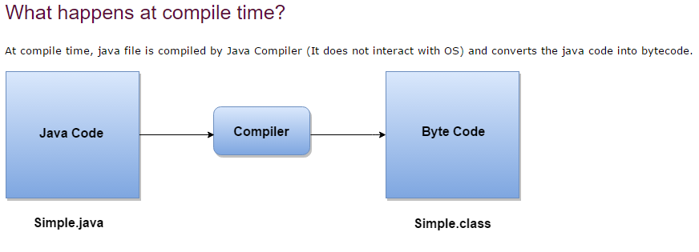

**->**

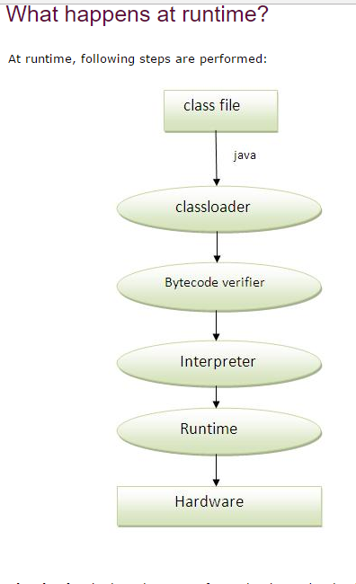

**How to set path in Java->**

**1.temporary.**

**2.permanent.**

**Set path temporary->**

**1.open cmd.**

**2.copy the path of jdk/bin directory.->//** **C:\Program Files\Java\jdk1.6.0_23\bin**

**3.write in cmd prompt :set path=copied_path//**

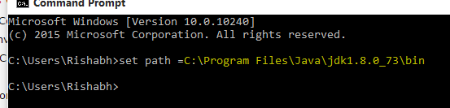

**Set path Permanetly->**

